The new automated data quality check on CDR

As announced in the last meeting of the Reporting Expert Group, the EEA has implemented an automated data quality check/quality assurance (QC/QA) to check the Natura 2000 envelopes that Member States submit to the European Commission.
We propose you to test and get used to the concept of QC/QA, using a so-called “Sandbox”, which is a system in which you can safely do tests, without compromising your official data. The CDR Sandbox replicates the CDR structure to which you are used to. Please note that the sandbox, unlike your official CDR, is shared with all users: do not include sensitive data in your test data.
After this testing phase, the QA tests will be used in the official CDR, probably by the end of 2019. The QC/QA tests will check your envelope, and allow its delivery only if all tests are passed. If QC/QA tests are not passed, you will have to apply the requested corrections. Envelopes failing the QC tests will not be delivered to the European Commission.
It is therefore crucial that you start getting familiar with this concept and be sure to be able to correct your standard data forms.
In this first test phase, only the fields “site code”, “site name”, “site type”, “biogeographical region” and “population size unit” are tested. For all of those fields, the QA-tests will check that a value is provided (presence), and for the population size unit, that the unit is defined. The conformity test checks that the provided values are defined in reference code lists. In the near future, more fields of the Standard Data Form will be tested and transformed into QC/QA test blockers.
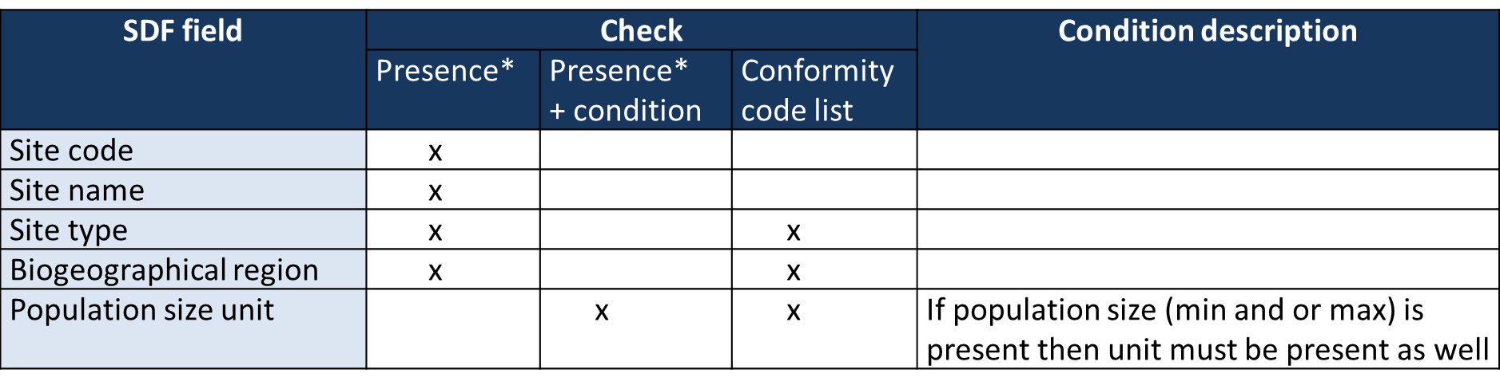
*Presence means the field must be filled in according to the rules defined in the SDF
The image below shows you that fields not conform with the tests will be reported with red stars and require that you correct them.
If you meet a technical problem at any step, please contact: helpdesk@eionet.europa.eu. If you need support related to the data content (such as how to correct your dataset and units or about an error message), please contact: natura2000.helpdesk@eionet.europa.eu.
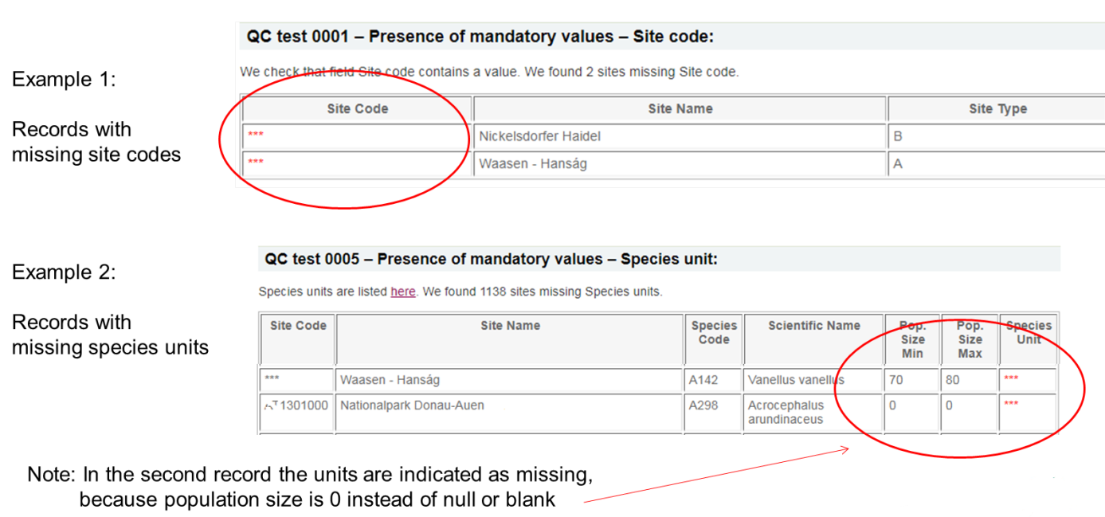
The rest of the document gives instruction to upload data and run a QC/QA test: you will be able to check if your dataset is conform with the current set of tests.

Step by step instructions
Please note that in its current version, the CDR Sandbox only processes the Standard Data Form (SDF) provided in xml format (not the MS-Access, mdb or accdb, format). If you are using MS-Access database for your standard data form, please consider to transform the Ms-Access format into the xml format. You can consider using the SDF manager software created by the EEA for this format transformation (https://github.com/eea/eionet.nat2000.sdfmanager/releases/tag/v4.3.0).
Step 1: open the CDR Sandbox page https://cdrsandbox.eionet.europa.eu and log-in with the generic user name “datareporter” and the password “datareporter”. The structure on CDR Sandbox is similar to the real CDR: there is no risk to corrupt your official data. Go to your country page, then into the “EU reporting obligations” folder and eventually to the “Natura 2000 network (Birds directive and Habitats directive)” reporting page.
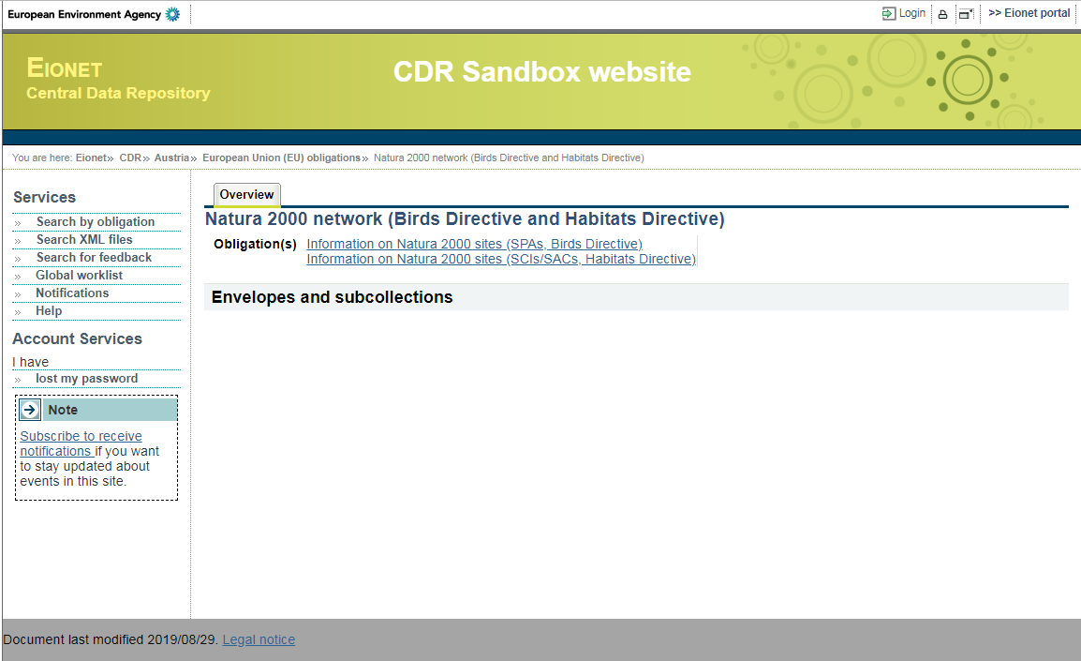

Step 2: Create a new envelope. It will be used to let you upload the xml formatted SDF database you want to test. Please do not include sensitive information in your test data. Click on the “New envelope” icon (top right of the page), then give it a name. This name will be useful to retrieve your tests afterwards (you will be able to delete them). For this test, the other fields (Description, reference years and coverage) are not important. Click “Add” to finalize.
After clicking on “Add”, you are back to the list of envelopes. Open the evelope you have just created: this will give you the possibility to add the xml file to test, by clicking on “Activate task” (see next step).
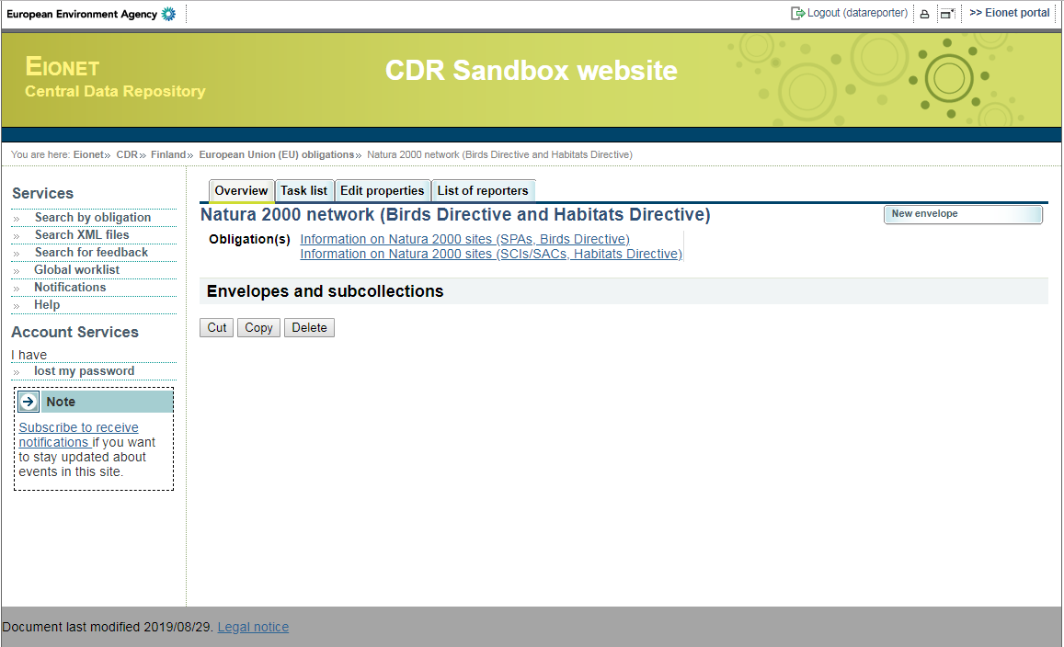
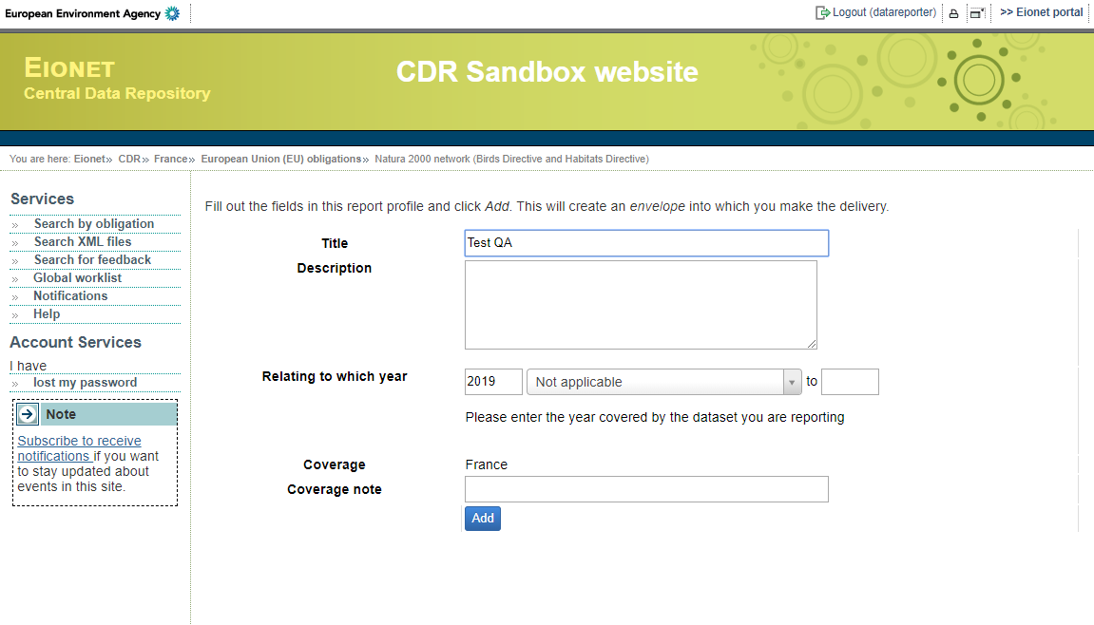

Step 3: By clicking on “Activate task”, a new page offers to add files to your envelope. Use “Add file” to be able to upload the xml file to test from your computer to the server (use the “choose file” button).
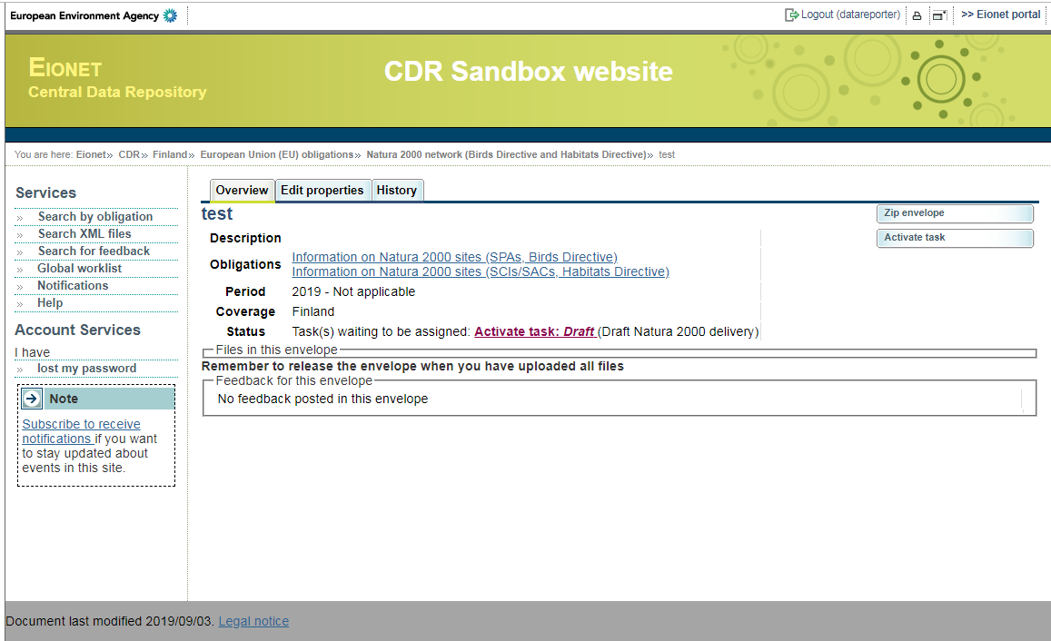
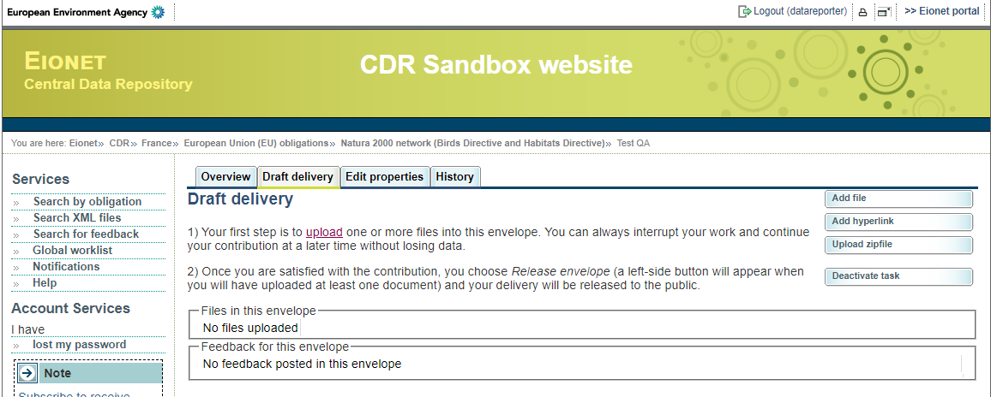

Step 4: Upload the xml file (which you can create using the SDF manager software).
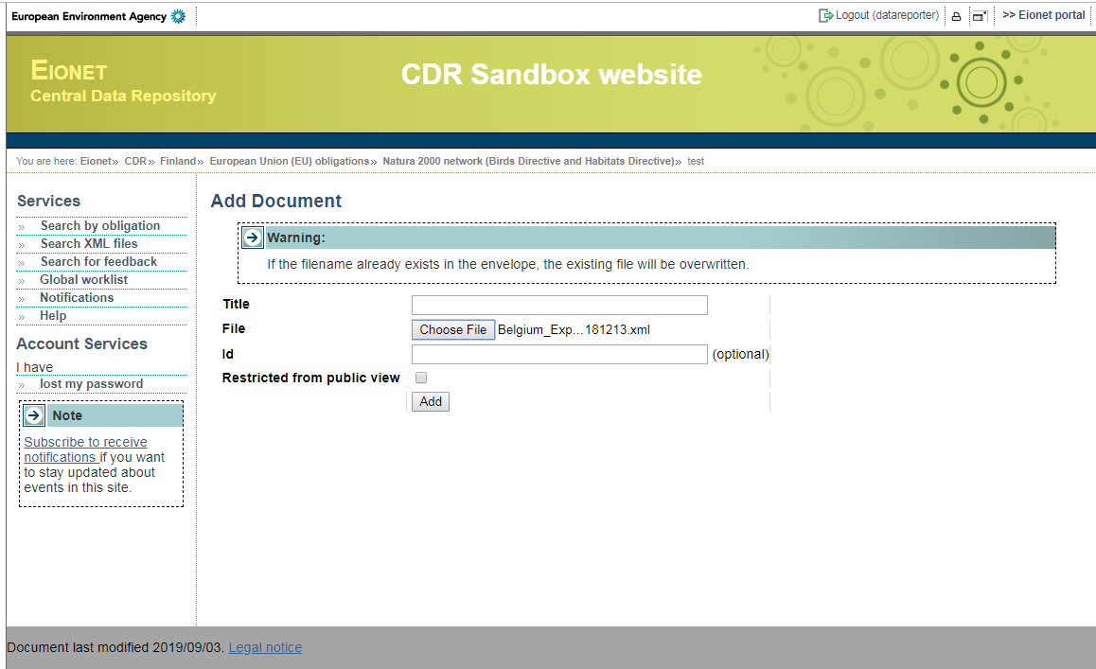

Step 5: Open your test envelope, and click on “Run Automatic QA”. The line “status” will show that the server is processing your envelope. While processing you will see two Task in progress statements. First “Delete all feedback” indicates that previous test results are being deleted, in case this is not the first time you test the envelope. The second status statement is “Automatic quality assessment”.
Do not use the “Run QA #1” button as previous test results may not be removed when using this option. It is meant for dataflows with more than one QA/QC test than can be run independently.
NOTE: A time-out error message may occur if there is too much traffic on the website (meaning that the processing failed). In this case try again after a couple of minutes.
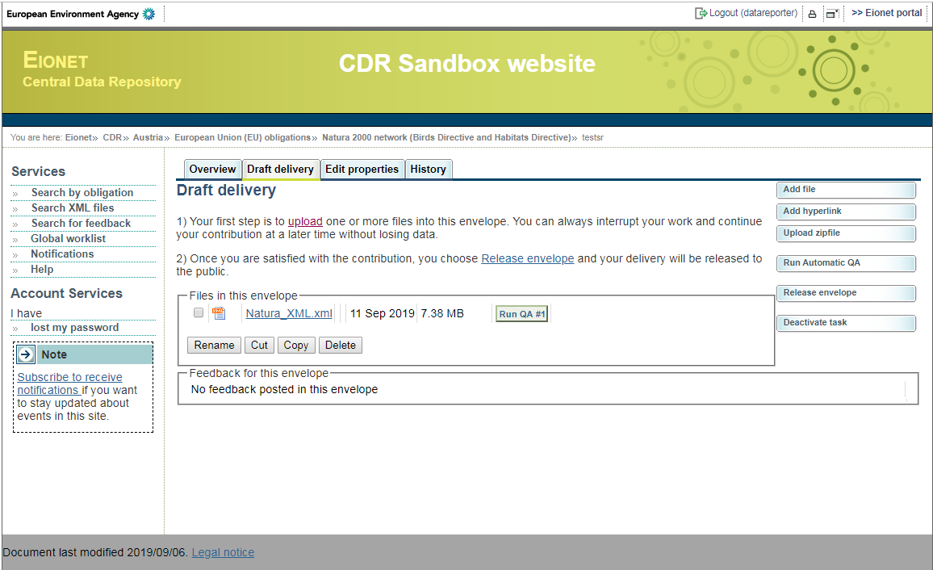
Towards the end of the Automatic quality assessment, the result (the “Feedback for this envelope”) becomes available.
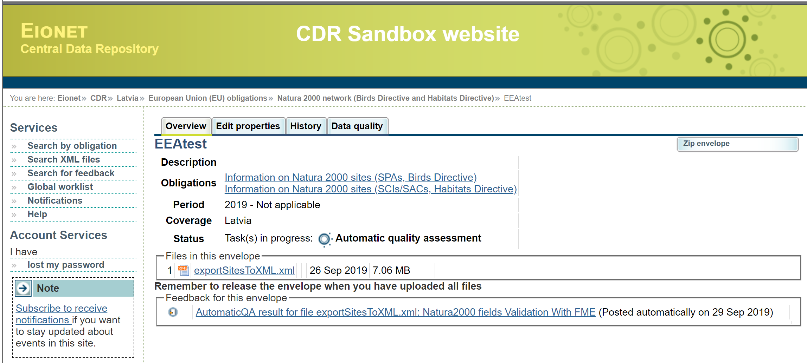

Step 6: Check the results and correct errors: fields which are not conform are reported with red stars. You must correct your SDF database and retry to pass the tests.
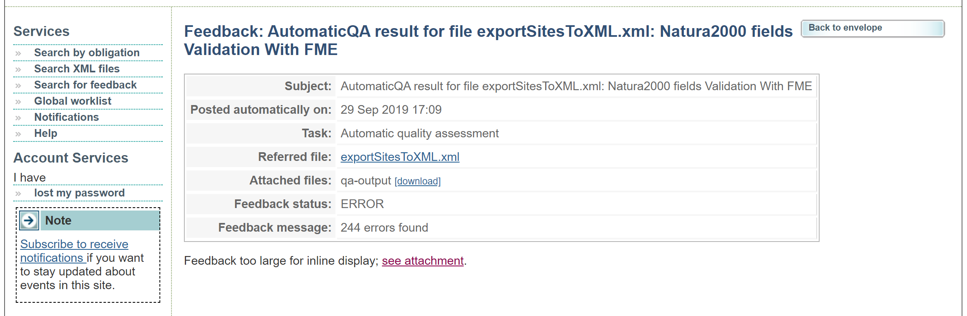
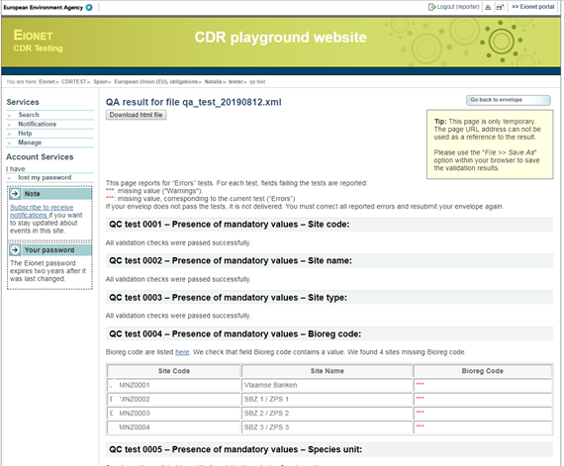

--- End of document ---

